**Lab – 51: Configure the ATA Gateway settings.**

**Objective:** The objective of this lab is –

* To configure the ATA gateway settings.

After the ATA Gateway was installed, we need to configure the settings for the ATA Gateway. So, in this lab we are going to configure the ATA gateway settings.

**Prerequisite:** Windows Server 2016. Windows server should be a member of a domain or workgroup. At least one network adapter. Microsoft .Net Framework 4.6.1 or later. Browser - Internet Explorer version 10 and above (or any other latest browser).

**Steps:**

1. In the ATA Console, go to **Configuration** and, under **System**, select **Gateways**.

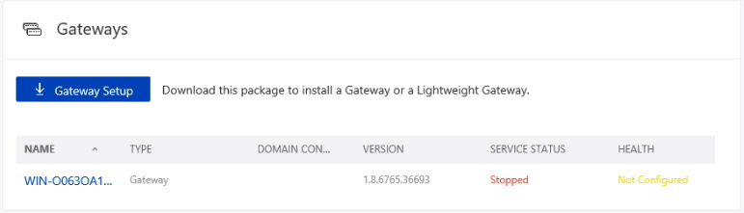

1. Click on the Gateway you want to configure and enter the details.

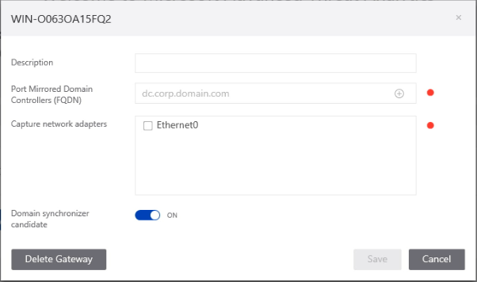

1. Enter a description for the ATA Gateway (optional) in the Description field.
2. Port Mirrored Domain Controllers (FQDN) - Enter the complete FQDN of your domain controller and click the plus sign to add it to the list. For ex. – corp.labdomain.com. after entering the domain controller click + sign that is shown in the text box field.
3. Capture Network adapters - For an ATA Gateway on a dedicated server, select the network adapters that are configured as the destination mirror port. These receive the mirrored domain controller traffic.
4. Domain synchronizer candidate - Any ATA Gateway set to be a domain synchronizer candidate can be responsible for synchronization between ATA and your Active Directory domain. Depending on the size of the domain, the initial synchronization might take some time and is resource-intensive. By default, only ATA Gateways are set as Domain synchronizer candidates.
5. After configuring all the settings click **Save**.

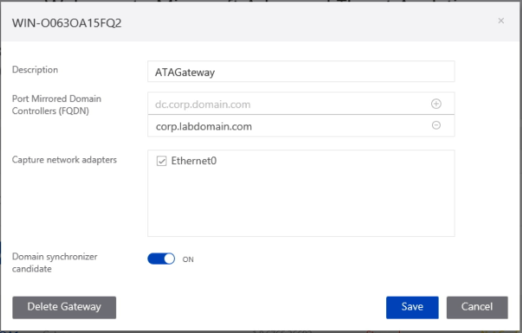

1. After saving, the status will be changed in the Gateways setting page and the service status is starting.

